43.41: a)
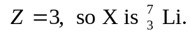
b)
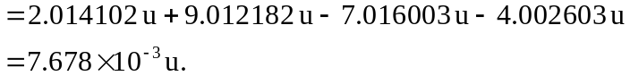
So
c) The threshold energy is taken to be the potential energy of the two reactants when they just “touch.” So we need to know their radii:
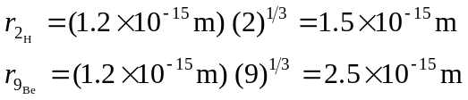
So the centers’ separation is 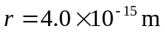
Thus 